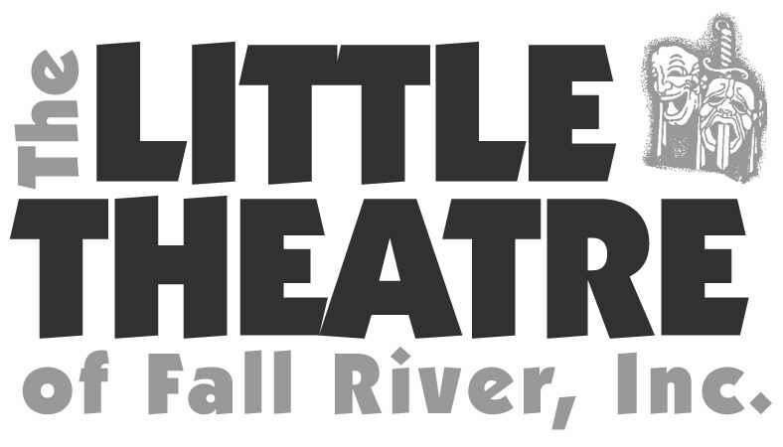
AUDITION ANNOUNCEMENT
The Rat Pack Lounge
AUDITIONS: Tuesday, May 15 and Wednesday, May 16 6:00pm @ the Firebarn 340 Prospect St. Fall River
Please prepare a song that will show off your voice; remember this is the Rat Pack. An accompanist will be provided. All races and ages are encouraged to audition for this show.
PERFORMANCE DATES: Thursday thru Sunday 10 performances July 19-29, 2018
Director/Music Director---Bobby Perry pianovamp@aol.com Please get in touch with any questions
Pat Taylor---Stage Manager 508-673-4104
SYNOPSIS: Frank, Dean and Sammy are up in heaven but God tells them they have some unfinished business back on Earth. It seems Frank made an unfulfilled promise to Vic, the owner of the Rat Pack Lounge. They have one night to make things right. No need for “look-alikes” or impersonators—just a cast who can charm an audience with over 30 hit songs like “My Way”, “What Kind of Fool Am I” “Everybody Loves Somebody Sometime”, etc. You’ll want to head back to the days of highballs and high rollers.

CAST BREAKDOWN:
Vic Candelino—Down on his luck owner of Vic’s Place; bankrupt, ready to throw in the towel.
Bobby Goldberg/Sammy Davis, Jr—The bartender; energetic and caring. His body is taken over by
Sammy Davis, Jr.
William Saunders/ Frank Sinatra—Real estate developer who wants to buy Vic’s Place and put up a
parking lot. His body is taken over by Frank Sinatra.
Katherine Kerr/ Angie—Mr. Saunders’ secretary. Type A personality. Her body is taken over by Angie;
a wiley angel from above
Jeorge Rodrigues/Dean Martin—Easy going guy. English is his 2nd language. He loves the Rat Pack.
His body is taken over by Dean Martin.

